**SMART WHEEL CHAIR FOR DISABLED PERSONS**

## A PROJECT REPORT

***Submitted by***

|  |  |
| --- | --- |
| ***MADHAVA KANNAN.N*** | ***211420105315*** |
|  |  |
| ***SYED SALMAN.U*** | ***211420105333*** |
| ***THARAN ROY*** | ***211420105334*** |
| ***THEJESHWAR.S*** | ***211420105336*** |
|  |  |
|  |  |
|  |  |
|  |  |
|  |  |
|  |  |
|  |  |
|  |  |
|  |  |
|  |  |

***in partial fulfilment for the award of the degree of***

**BACHELOR OF ENGINEERING**

***in***

## ELECTRICAL AND ELECTRONICS ENGINEERING



**PANIMALAR ENGINEERING COLLEGE**

**(An Autonomous Institution, Affiliated to Anna University, Chennai)**

## MAY 2023

**PANIMALAR ENGINEERING COLLEGE**

**(An Autonomous Institution, Affiliated to Anna University, Chennai)**

**BONAFIDE CERTIFICATE**

Certified that this project report **“SMART WHEEL CHAIR FOR DISABLED PERSONS”** is the bonafide work of **“MADHAVA KANNAN.N (211420105315), SYED SALMAN.U (211420105333), THARAN ROY (211420105334),THEJESHWAR.S (211420105336)”** who carried out the project work under my supervision.

**SIGNATURE SIGNATURE**

Dr.S.SELVI (M.E, Ph.D.) V.DEVARAJ (M.E, Ph.D.)

**HEAD OF THE DEPARTMENT SUPERVISOR PROFESSOR**

Department of Electrical and Department of Electrical and

Electronics Engineering, Electronics Engineering, Panimalar Engineering College, Panimalar Engineering College, Chennai-600 123. Chennai-600 123.

Submitted for End Semester Project Viva Voce held on 03/05/2023 at Panimalar Engineering College, Chennai**.**

**INTERNAL EXAMINER EXTERNAL EXAMINER**

## ACKNOWLEDGEMENT

We would like to express our sincere thanks to our respected Chairman and Chancellor, Sathyabama University **Dr.JEPPIAR M.A., B.L., Ph.D.,** for being in the vanguard of scientific progress in our college.

We would like to express our deep gratitude to our Beloved Secretary and Correspondent **Dr. P.CHINNADURAI M.A., Ph.D**., for extending his never ending support to us.

We extend our sincere thanks to our Professor & Head of the Department, Electrical and Electronics Engineering, **Dr. S. SELVI M.E, Ph.D.**

We are thankful and forever indebted to our Project Supervisor ,**V.DEVARAJ (M.E, Ph.D.,)** Professor for his insightful feedback and prompt assistance in completion our project.

We also extend our thanks to **All Staff Members** of Electrical and Electronics Engineering for their support and technical assistance. On a personal note, we would like to express our heartfelt thanks to our beloved **Parents** and our Friends, for their help and wishes in successfully completing this project. Thanks to **Almighty** for giving us the strength to do this project successfully.

## ABSTRACT

With the advancement of science and Technology an innovative mechanism is adopted to provide the assistance for physically challenged personalities. Spinal card injury persons and physically challenged persons required human assistance to move from one point to another point. The spinal card injury makes the people to paralysed, by this they need to depend on others for their movement. Electronics interfaced Wheel chair had designed to move without any assistance. A Microcontroller with a combination of sensors is used to direct the movement of the device. The wheel chair may move forward, backward, left and right directions based on the output signal of the sensor. And also wheel chair is controlled by voice commands through google assistant. The developed wheel chair is best suited to meet the challenges of the physically challenges personalities and also provide them an easy control of wheel chair.

## TABLE OF CONTENTS

|  |  |  |
| --- | --- | --- |
| **CHAPTER NO** | **TITLE** | **PAGE NO** |
| **1.** | **INTODUCTION** | **1** |
|  | * 1. TYPES OF WHEELCHAIR      1. All-Terrain wheelchair      2. Manual Wheelchair      3. Electrical Wheelchair      4. Airplane Wheelchair      5. Beach Wheelchair      6. Bariatic Wheelchair      7. Ergomic Wheelchair      8. Pediatric Wheelchair      9. Reclining Wheelchair      10. Single Arm Wheelchair   2. DISABLED PEOPLE AROUND THE WORLD |  |
| **2.** | **LITERATURE SURVEY** | **11** |
| **3.** | **SYSTEM DESIGN** | **18** |
|  | * 1. EXISTING SYSTEM   2. PROPOSED SYSTEM |  |
| **4.** | **HARDWARE REQUIREMENTS** | **20** |
|  | * 1. ARDUINO UNO microcontroller      1. Architecture of ARDUINO UNO      2. General Description      3. Specifications of ARDUINO UNO   2. MOTOR      1. General Description      2. Features   3. DRIVER CIRCUIT      1. L298N Motor Driver      2. Specifications   4. IR PROXIMITY SENSOR      1. General Description      2. Product Description      3. Application   5. ULTRA SONIC SENSOR      1. General Description      2. Product Description      3. Formulae Used      4. Specification |  |

|  |  |  |
| --- | --- | --- |
| **5.** | **SOFTWARE REQUIREMENTS** | **31** |
|  | * 1. GOOGLE ASSISTANT      1. Google assistant on phone      2. Features   2. SOFTWARE DESCRIPTION      1. Arduino IDE      2. Hardware Needed      3. Source Code      4. Technical Details   3. USD OVERCURRENT PROTECTION      1. Physical Characteristics and shield Compatibility      2. Instruction to use Arduino   4. EMBEDDED C      1. About Embedded C      2. Description      3. Multiple Address Spaces      4. Named Registers      5. I/O Hardware Addressing      6. Embedded C Portability |  |
| **6** | **CONCLUSION AND FUTURE SCOPE** | **57** |
|  | **REFERENCES** | **58** |

**LIST OF ABBREVIATIONS**

|  |  |
| --- | --- |
| **WHO** | World Health Organization |
| **IEEE** | Institute of Electrical and Electronics Engineers |
| **FCR** | False Command Rate |
| **EEG** | Electro Encephalo Gram |
| **ESP** | Extrasensory Perception |
| **Wi-Fi** | Wireless Fidelity |
| **MPU** | Memory Protection Unit |
| **LED** | Light Emitting Diode |
| **MEMS** | Micro- Electro mechanical Systems |
| **IOT** | Internet Of Things |
| **SOC** | System of Chip |
| **TSMC** | Taiwan Semiconductor Manufacturing Company limited |
| **SAR** | Specific Absorption Rate |
| **PWM** | Pulse Width Modulation |
| **IC** | Integrated Circuit |
| **IDE** | Integrated Development Environment |

*CHAPTER 1 - INTODUCTION*

It’s a widespread nature of a human being to walk independently as a by-born nature. But sometimes, some reason causes the interruption of this character. Superior stage of spiral cord damage, accident and brain as well as nervous system anarchy are such types of cases which causes inhabitants to loss control of arms or legs or together arms. In addition, physical disorder at the time of born also makes people immobilize. However, wheelchair is the way to make this group to being able to move. But, in the occasion of upper limb injury, it restricts some to the use of manual wheelchair, which is operated by arm’s muscular strength. So, they have to depend on others to give the manual force to move the wheelchair. To remove this enslavement and progress the feature of their life, present science made a progression on wheelchair history, which eliminates some of the mobility problems. Electric Powered Wheelchair is the solution, which is commonly branded as Automatic Wheelchair. The wheelchair where an electric motor moves the chair in spite of labor-intensive power as known as motorized wheelchair, electric wheelchair power chair, or electric-powered wheelchair.

Old citizens or disabled persons become dependent on other members of the family to navigate through their habitat or within residence. A smart wheel chair can be a useful assistant for them. Recent development in the field of robotics, automation, embedded system, artificial intelligence etc. can be combined & utilized to design such a wheel chair. It can be controlled wirelessly adopting proper communication system. The chair can be controlled by voice, Bluetooth joystick, can also be made to run on

single path of line, joystick method with directions as needed. The previous development of this kind of wheel chair is using a laptop or PC on the wheel chair [1]. By this development the recent wheel chairs are wireless controlled or voice controlled [2]. But the limitations of this kind of technologies is that the wheel chair is getting too bulky and it is to be controlled only by sitting on it. That’s why these types of wheel chairs are not giving satisfactory feedback from the users. The proposed model makes the wheel chair a lot easier to assemble and simple in the use, in addition the cost of manufacturing also gets reduced.

A major task of designing a smart wheelchair control is to produce sufficient commands rapidly and accurately including left and right turns, forward and backward motions, stopping, acceleration and deceleration. The facilities provided by a typical wheelchair require people with disabilities having intact manipulation ability like to use a joystick and operate the vehicle. However, many people with disabilities can not manipulate mechanical device and thus unable to use typical wheelchair. People with limited muscular function usually suffer from Amylotropic Lateral Sclerosis (ALS), paralysis and other Motor disabilities which causes loss of body movement.

## TYPES OF WHEELCHAIR

* + 1. **All- Terrain Wheelchair**

One of the most unusual types of power wheelchairs, these are niche products, but well worth a mention. They feature large inflated tires (and sometimes tank tracks!) with deep treads that enable them to go over just about any terrain.

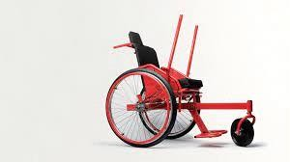

Fig1.1 All-Terrain Wheelchair

## Manual Wheelchair

These are what most people think about when you mention the phrase. Most commonly seen in hospitals and nursing homes, they are the most economical choice for most people.

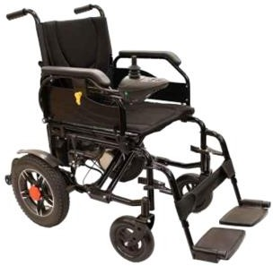

Fig 1.2 Manual Wheelchair

## Types of Manual Wheelchair

We can also divide this sub-category of wheelchairs according to their use:

* + - * Lightweight
      * Sports
      * Pediatric
      * Reclining
      * Transport
      * Heavy Duty
      * Hemi-Height

## Electrical Wheelchair

Electric wheelchairs are far and away the most popular variety because they allow those who use them greater freedom of mobility without having to rely on a nurse or other assistant, except perhaps for getting into the chair.

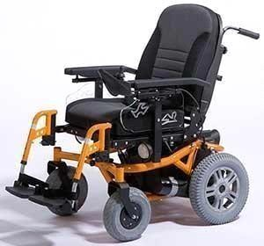

Fig 1.3: Electrical Wheelchair

## Airplane Wheelchair

This is another niche product, primarily used by airlines to facilitate transport of people who have disabilities, but if you have and travel frequently, you can certainly invest in one privately as well.

They tend to be smaller and lighter than traditional manual wheelchairs, being designed to pass between the rows of seats on an airplane, and come with safety buckles so that you can buckle up while in flight, just like all the other passengers.

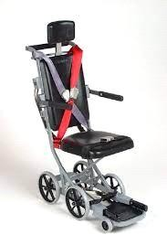

Fig 1.5: Airplane Wheelchair

## Beach Wheelchair

Another highly specialized design, these are almost always made from PVC or hollow aluminum tubes, with almost cartoonishly large wheels to make it easier to traverse the sand. Just because you have mobility issues doesn’t mean you have to be limited in the things you can do or enjoy!

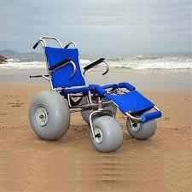

Fig 1.6: Beach Wheelchair

## Bariatric Wheelchair

This is another highly-specialized type of chair, expressly designed with obese patients in mind. Constructed on a sturdier frame with a wider seat, these chairs provide the full range of mobility options to people who suffer from extreme weight issues.

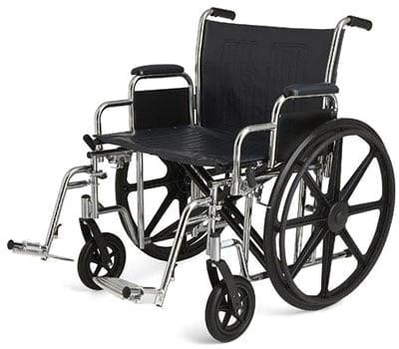

Fig 1.7 : Bariatic Wheelchair

## Ergonomic Wheelchair

An ergonomic wheelchair is designed as a synthesis of a standard, manual wheelchair, merged with an ergonomic office chair with superior They’re ideal chairs for people who spend extended periods of time sitting down**.**

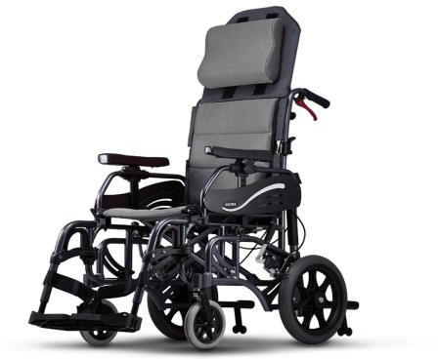

Fig 1.8: Ergonomic Wheelchair

## Pediatric Wheelchair

Kid-sized wheelchairs, these are functionally identical to their full-sized cousins, just made smaller to better fit their users.

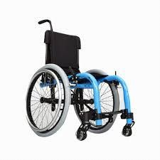

Fig 1.9 : Pediatric Wheelchair

## Reclining Wheelchair

An exceptional niche design, offering all the benefits of a recliner, rolled into a wheelchair. These designs come with a pillow to offer greater comfort when resting in a reclined position. While it’s possible to nap in chairs of this type, you’llalmost certainly want extra padding if this is your intention.

## Single Arm Wheelchair

If there’s one limitation of manual wheelchairs, it is that the user, by necessity needs both arms to propel the chair. If you try to just use a single arm, you’ll wind upgoing in circles and get nowhere fast. The single-arm drive wheelchair solves this problem by connecting the two wheels by a specially-shaped axle, allowing you to move forward using only one arm.

## Sports (Racing) Wheelchair

[Sports wheelchairs](https://www.ncbi.nlm.nih.gov/pubmed/1832786) are constructed the same way as a standard wheelchair, except that the large rear wheels are angled in toward the seat**,** allowing for tighter turns, and enabling users to engage in a full range of sports activities (tennis,basketball, etc.).

## Standing Wheelchair

As the name implies, this type of wheelchair is designed for use while standing. Most models allow for reconfiguration so they can be utilized in both seated and standing positions. While not the most technically advanced design currently available, this type of chair has the distinction of turning the user into a kind of living Transformer, just like in the movies!

## Tilt Wheelchair

In the world of wheelchairs, there’s a raging debate about which is superior: [reclining or tilt wheelchairs](https://mobilitymgmt.com/Articles/2014/11/01/Tilt-Recline.aspx) They both accomplish the same basic goal although they achieve it via different means.

These are the best types of wheelchairs for cerebral palsy patients if a recline feature is desired.

## Ultralight Wheelchair

Ultra-light wheelchairs are, as their name implies, significantly lighter than their main stream counterparts. To accomplish this, they make certain concessions, including a shortened seat back, and being constructed with lighter-weight materials.

## Wheelchair Stretcher

An intriguing design not typically purchased for home use, but used by EMTs and hospital professionals. They’re lightweight wheelchairs that can recline 180 degrees, effectively becoming a stretcher when the catch is released. In the picture below, note the presence of two sets of handles.

## The i-Bot

There is one additional type of wheelchair worth mentioning. We didn’t list it among the major types, because it’s cutting edge technology and not yet widely available, but that’s changing.

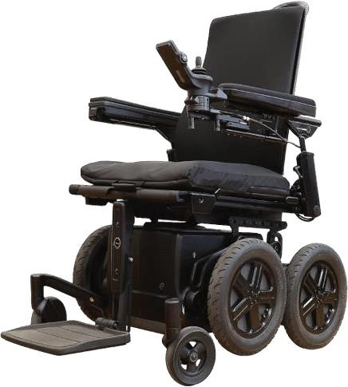

Fig 1.9 : iBot

## Disabled peoples around the world

There are currently more than 1 billion disabled people in the world. According to the World Health Organization (WHO) a disabled person is anyone who has “a problem in body function or structure, an activity limitation, has a difficulty in executing a task or action; with a participation restriction”.

75 million people need a wheelchair on a daily basis. This represents 1% of the world’s population. That’s twice Canada’s population!

In addition to born disabilities, due to accidents there are many people lost their legs due to which their mobility are affected. The need to depend on others for their movement. Spinal card injury may cause people paralysed. Partial paralysed or fully paralysed made them to need wheelchair for their movement.

Other than these things due to aging many people lack the stamina to move. These elderly people need wheelchair for their movement.

# CHAPTER 2 - LITERATURE SURVEY

## WIRELESS HEAD GESTURE CONTROLLED WHEEL CHAIR FOR DISABLE PERSONS

**Abstract**

This paper describes an indigenously developed hands-free wheel chair for physically disabled persons. The proposed device works based on the Head Gesture Recognition technique using Acceleration sensor. Conventional electric powered wheel chairs are usually controlled by joysticks or hand gesture technology which cannot fulfil the needs of an almost completely disabled person who has restricted limb movements and can hardly move or turn his head only. Acceleration sensor is used for the head gesture recognition and RF (radio frequency) module is used for the smart wireless controlling. With the change of head gesture, data is sent wirelessly to the Microcontroller based motor driving circuit to control the movement of the Wheel Chair in five different modes, namely FRONT, BACK, RIGHT, LEFT and a special locking system to STAND still at some place. The proposed device is fabricated using components collected from local market and tested in lab for successful functioning, test results are included in this paper.

**PUBLISHED IN**: 2017 IEEE .

**AUTHOR**: Shayban Nasif, Muhammad Abdul Goffar Khan**.**

## STEERING CONTROL IN MULTI-DEGREES-OF-FREEDOM TWO- WHEELED WHEEL CHAIR ON SLOPE ENVIRONMENT

**Abstract**

As the development of electrical transportation systems, two-wheeled mobile robots have been widely studied because of the high mobility. Among them, the two - wheeled wheel chair is the wheel chair without caster wheels, and moves and stabilizes with only two wheels. However, wheel chairs cannot move lateral direction in general, and they sometimes fall down and cause into serious accidents. In this paper, lateral directional mode and its control method are proposed to solve this problem, and the validity of proposal is checked through simulations. The results are evaluated by the movement distance and the change of body’s pitch angle. Index Terms—Two-wheeled wheel chair, Stabilized Control, Observers, Sensor-less Control, Mobile Robots, Steering Control, Multi-degrees-of-freedom

**AUTHOR**: Sakurako HAMATANI, Takahiro NOZAKI .

## EYE BLINK CONTROLLED LOW COST SMART WHEEL CHAIR AIDING DISABLED PEOPLE

**Abstract**

In this paper, a smart wheelchair is proposed to help out physically disabled people by using their eye blink activities. A prototype is implemented by processing eye ball images of the subject to detect intentional eye blinks. An algorithm is proposed to produce wheelchair movement command from consecutive intentional eye blinks. To identify intentional eye blinks from eye ball images, advanced image

processing techniques are applied using raspberry-pi. The commands are wirelessly transferred to the motor driver of the wheel chair. The HC-05 Bluetooth receiver is connected to the wheelchair which receives transmitted data from raspberry-pi and motor driver implements the command according to predefined decision table. It can also sense obstacle using APDS 9960 proximity sensor to avoid collision with surroundings. The proposed smart wheelchair has shown False Command Rate (FCR) of 2.1% to 13.2%. The experiment is performed on four subjects and each of them has attended three sessions. Overall, the eye blink controlled aiding wheelchair is going to create a humanitarian impact on physically disabled people.

**AUTHOR**: Md Ashiqur Rahman Apu, Imran Fahad, S. A. Fattah, Celia Shahnaz.

## WHEEL THERAPY CHAIR: A SMART SYSTEM FOR DISABLED PERSON WITH THERAPY FACILITY

**Abstract**

Each and every person in this world has a desire to live a normal human life but accidents, diseases, elder-ship make their desire into disability. Moreover, there are lots of handicaps and elders as well as the number of paralyzed people are increasing day by day. They always need another person in moving and have to go under some physical therapies under the guidance of a therapist to recuperate their strain back. In this paper the proposed system helps them to move freely & safely and also takes the activities of a therapist in a cost effective manner. This system is a combination of different controlling features, has the ability to detect obstacle and provides few kinds of therapies.

A smart wheelchair is developed by using voice recognition system to control the movement of wheelchair and also with Arduino

interfaced joystick. Besides, an ultrasound system provides the facility of automatic obstacle detection. The aim of research is to compact many facilities in a single wheelchair at low cost.

**AUTHOR**. [.](https://ieeexplore.ieee.org/author/37086799586) Md. Mamunur Rahman, Swarup Chakraborty

## DEVELOPMENT OF A SMART WHEELCHAIR WITH DUAL FUNCTIONS: REAL-TIME CONTROL AND AUTOMATED GUIDE

**Abstract**

Wheelchairs are devices used for mobility by people whose walking is difficult or impossible, due to illness or disability. There are many types of wheelchairs, including basic, light-weight, folding, multi-function, special types, and so on. Each of them has its advantages and disadvantages. Development of brain-computer interface applications has become quite popular in recent year. It allows direct communication between brain and computer. One type of the communication is by imagination. By analyzing the EEG signals under imagination, different features could be calculated to transform into instructions for the control of back-end robotic device. Since brain-computer interface allows users to control the instruments without the need of physical input, it may be suitable for patients with physical defects or limb weakness. Therefore, this study aimed to design a smart wheelchair which has real-time control and automated guided functions. We based on the advantages of simple and rapid construction in LabVIEW to develop the smart wheelchair. This system was able to control our own-made wheelchair model with dual functions. In the real-time control function, our results show that the

average accuracy of the imagination to the left was 70% and the average accuracy of the imagination to the right was 60%. In the automated guided function, our results

tested in small-area (20m · 20m in space) shows that wheelchair could move along the pre-setting path. In the future, we want to improve the whole system and make this prototype wheelchair more practical as using a real wheelchair instead of a wheelchair model. We hope to make this functional wheelchair more humane, so that the wheelchair is not only comfortable and safe but also has multiple functions to improve patient's quality of life and reduce the burden of care from their families.

**Author:** Chung-Kang Huang; Zuo-Wen Wang

## IOT BASED WHEELCHAIR FOR DISABLED PERSONS

**Abstract**

Smart Wheelchair is known as a Power Wheelchair that is integrated into multiple sensors, assistive technology, and computers that give the user with a disability such as impairment, handicaps, and permanent injury, the required mobility to move freely and safely. These types of wheelchairs are gradually replacing the traditional wheelchairs; however, their expensive costs are preventing a large size of disabled people from having one. According to the organization of World Health (WHO), only 5 to 15% out of 70 million disabled people have access to wheelchairs. Therefore, we need to offer a cost- effective Smart that not only minimized the cost but also provides plenty of features that

use the latest components and technologies. In the last years, there have been many pleasant efforts that serve this purpose. They have adopted various technologies such as artificial intelligence, where they have designed an autonomous wheelchair that used machine learning concepts to navigate, and some also used Internet of Thing technology to control the wheelchair-using voice recognition system. This report will present a cost-effective

Smart Wheelchair-based Arduino Nano microcontroller and IoT technology that have several features to gain disabled people, especially poor people who cannot afford expensive Smart Wheelchair, the required help to finish daily life tasks without external help. To conclude this project will make the Smart Wheelchair affordable to a wide range of disabled people and will be based on Arduino Nano, ESP-12e module to give Wi-Fi access, MPU6050 to detect fall with Voice message notification using IFTTT platform, obstacle detection with buzzer and LED to work as hazards, voice recognition system, and joysticks to control the wheelchair.

## Smart Wheelchair for Physically Challenged People Abstract

According to the World Health Organization (WHO), in the world population, there around 70 million people who requires the need for wheelchairs, yet only 5- 15% have access to it. The wheelchair we developed here is very cost effective and aids the people who are disabled and physically challenged. The wheelchair allows them to maneuver around their surrounding with ease without the intervention of another person, allowing them to be independent.

## Designing of a Smart Wheelchair for People with Disabilities

**Abstract**

There are many people with disabilities in this day and age who find it is impossible to learn or perform day to day tasks. Some of these kinds of people rely

on others for their assistance. Whichever way, they can become autonomous and conduct a few routine exercises with the assistance of helpful gadgets. The most used support devices are wheelchairs. The main purpose of wheelchairs is to provide help to people who are unable to walk because of sickness, handicaps or damage. However, there are also elderly persons with weak appendages and seals who cannot move the wheelchair. Smart wheelchairs will therefore gain a tone for them, and anyone else in the public eye. Intelligent wheelchairs are electrically operated wheelchairs with many other components, such as a PC and sensors, which help the consumer and clockmaker to handle wheelchairs safely and efficiently. Signal growth and autonomous mechanics contribute to the creation of new wheelchairs in the fields of artificial intelligence. This paper is designed to improve the maneuvering tasks of an intelligently self-contained wheelchair. In addition to computer-based treatment, no human intervention during navigation and perception is needed in the wheelchair.

# CHAPTER 3 - SYSTEM DESIGN

## EXISITNG SYSTEM

In existing system, the wheel chair is operated using WIFI ESP-12ewhich is interfaced with the Arduino NANO controller. The main disadvantage is it can lose connection in certain conditions. It has low bandwidth. It allows only short range communication between devices. This is considered as the main disadvantage of the existing method.

## PROPOSED SYSTEM

Assistive technology for physically challenged personalities had wide scope in present research era. The major concept of our project is to provide an assistive wheel chair working based on IR proximity sensor module, IR kit, Ultrasonic sensor which is connected to micro controller. The motor driver which is connected with the controller is used to control the movement of the wheel chair based on the data taken from the Sensors & HC-05 module & it is controlled by Google assistant, wireless joystick connected Via Bluetooth , line follower is connected with the HC-05 to make it run by the orders taken from the Transmitter (BT connected via Mobile phone) & obstacles avoidance is added to the Micro Controller.

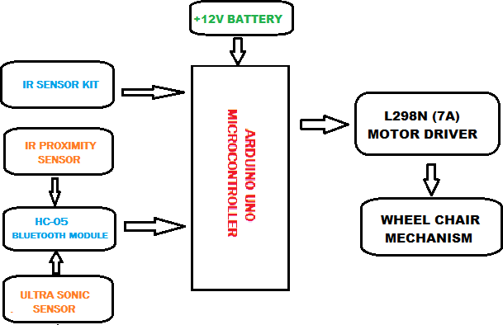

Fig 3.1: Block diagram of proposed system

The wheelchair is controlled by wireless joystick, voice control & a IR transmitter remote. The chair movement is controlled microcontroller and the voice control is controlled by google assistant via the HC-05 module . The input is given by transmitter (Mobile connected to the HC-05) or Ultrasonic sensor to the micro controller. According to the input by sensors, microcontroller gives input to the driver and the driver controls the wheelchair. The input for the system is given by 12V battery which can be rechargeable.

# CHAPTER 4 - HARDWARE REQUIREMENTS

## ARDUINO UNO Microcontroller:-

The Arduino Uno is an open-source microcontroller board based on the Microchip ATmega328P microcontroller and developed by Arduino.cc and initially released in 2010.[2][3] The board is equipped with sets of digital and analog input/output (I/O) pins that may be interfaced to various expansion boards (shields) and other circuits.[1] The board has 14 digital I/O pins (six capable of PWM output), 6 analog I/O pins, and is programmable with the Arduino IDE (Integrated Development Environment), via a type B USB cable.[4] It can be powered by a USB cable or a barrel connector that accepts voltages between 7 and 20 volts, such as a rectangular 9-volt battery. It is similar to the Arduino Nano and Leonardo. The hardware reference design is distributed under a Creative Commons Attribution Share-Alike 2.5 license and is available on the Arduino website.

Layout and production files for some versions of the hardware are also available.

The word "uno" means "one" in Italian and was chosen to mark a major redesign of the Arduino hardware and software.[7] The Uno board was the successor of the Duemilanove release and was the 9th version in a series of USB-based Arduino boards.[8] Version 1.0 of the Arduino IDE for the Arduino Uno board has now evolved to newer releases.[4] The ATmega328 on the board comes preprogrammed with a bootloader that allows uploading new code to it without the use of an external hardware programmer.[3]

While the Uno communicates using the original STK500 protocol, it differs from all preceding boards in that it does not use a FTDI USB-to-UART serial chip. Instead, it uses the Atmega16U2 (Atmega8U2 up to version R2) programmed as a USB-to-serial converter.

## Architecture of ARDUINO UNO

Basically, the processor of the Arduino board uses the Harvard architecture where the program code and program data have separate memory.

It consists of two memories such as program memory and data memory.

Wherein the data is stored in data memory and the code is stored in the flash program memory.

The Atmega328 microcontroller has 32kb of flash memory, 2kb of SRAM 1kb of EPROM and operates with a 16MHz clock speed.

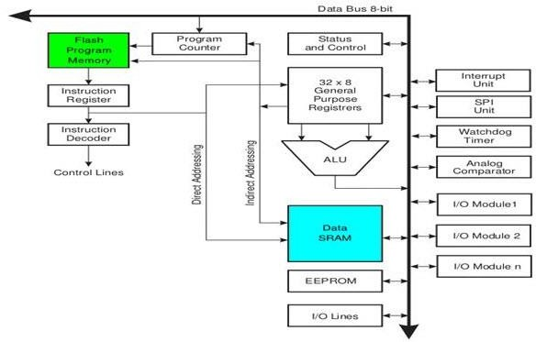

Fig 4.1: Architecture of Arduino UNO microcontroller

## General Description

An Arduino board is a one type of [microcontroller](https://www.watelectronics.com/differences-between-microprocessor-and-microcontroller/) based kit. The first Arduino technology was developed in the year 2005 by David Cuartielles and Massimo Banzi. The designers thought to provide easy and low cost board for students, hobbyists and professionals to build devices. Arduino board can be purchased from the seller or directly we can make at home using various basic components. The best examples of Arduino for beginners and hobbyists includes motor detectors and thermostats, and simple robots. In the year 2011, Adafruit industries expected that over 3lakhs Arduino boards had been produced. But, 7lakhs boards were in user’s hands in the year 2013. Arduino technology is used in many operating devices like communication or controlling.

A typical example of the Arduino board is Arduino Uno .It includes an ATmega328 microcontroller and it has 28-pins

The pin configuration of the Arduino Uno board is shown in the figure 4.2

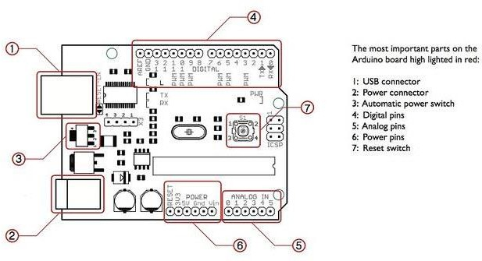

Fig 4.2: pin configuration

It consists of 14-digital i/o pins. Where in 6 pins are used as pulse width modulation o/ps and 6 analog i/ps, a USB connection, a power jack, a 16MHz crystal oscillator, a reset button, and an ICSP header.

Arduino board can be powered either from the personal computer through a USB or external source like a battery or an adaptor

This board can operate with an external supply of 7-12V by giving voltage reference through the IORef pin or through the pin Vin.

## Arduino Uno Specification

Arduino UNO is a microcontroller board based on the ATmega328P. It has **14 digital input/output pins (of which 6 can be used as PWM outputs), 6 analog inputs, a 16 MHz ceramic resonator, a USB connection, a power jack, an ICSP header and a reset button** Microcontroller: ATmega328P

* + - * Operating Voltage: 5V
      * Input Voltage (recommended): 7-12V
      * Output Voltage (limit): 6-20V
      * Digital I/O Pins: 14 (of which 6 provide PWM output)
      * PWM Digital I/O Pins: 6
      * Analog Input Pins: 6
      * DC Current per I/O Pin: 20 mA
      * DC current for 3.3V Pin: 50 mA
      * Flash Memory: 32 KB (ATmega328P) of which 0.5 KB used by bootloader
      * SRAM: 2 KB (ATmega328P)
      * EEPROM: 1 KB (ATmega328P)
      * Clock Speed: 16 MHz
      * LED_BUILTIN: 13
      * Length: 68.6 mm
      * Width: 58.4 mm
      * Weight: 25 g

## 12v planetary Motors :-

* + 1. **General Description**

A planetary gearboxes **consist of an internal sun gear that drives multiple outer ring gears known as planet gears**, hence its name. Multiple contact points across the planetary gearbox design allows for higher torque generation compared to a spur gear motor

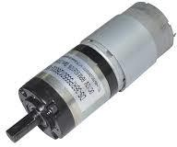

Fig 4.3: Planetary motor

## Features

Rated Speed : upto 1400 Rated Torque: upto 20Nm Diameters : 6mm ~ 90mm Voltages : 6VDC~48VDC

## DRIVER CIRCUIT

* + 1. **L298N Motor Driver:-**

The L298N chip contains two standard H-bridges capable of driving a pair of DC motors, making it ideal for building a two-wheeled robotic platform.

The L298N motor driver has a supply range of 5V to 35V and is capable of 2A continuous current per channel, so it works very well with most of our DC motors.

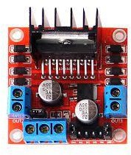

Fig 4.4: L298N Motor Driver

## Specifications

|  |  |
| --- | --- |
| Motor output voltage | 5V – 35V |
| Motor output voltage | 7V – 12V |
| Logic input voltage | 5V – 7V |
| Continuous current per channel | 2A |
| Max Power Dissipation | 25W |

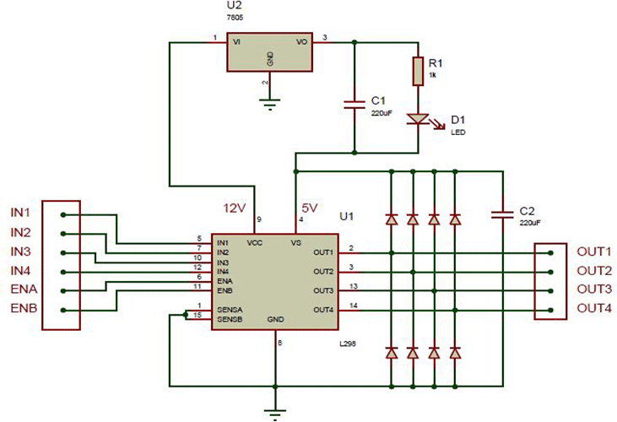

Fig 4.5: Internal circuit of Motor Drive

## IR PROXIMITY SENSOR :-

* + 1. **General Description**

IR sensor is an electronic device, that emits the light in order to sense some object of the surroundings.

An [**IR sensor**](https://robu.in/product-category/sensor/ir-and-pir-sensor/) can measure the heat of an object as well as detects the motion.

Usually, in the [**infrared spectrum**](https://en.wikipedia.org/wiki/Infrared_spectroscopy), all the objects radiate some form of thermal radiation.

These types of radiations are invisible to our eyes, but infrared sensor can detect these radiations.

The emitter is simply an IR LED [**(Light Emitting Diode**](https://robu.in/product-category/display-boards/led/)) and the detector is simply an IR photodiode.

Photodiode is sensitive to IR light of the same wavelength which is emitted by the IR LED. When IR light falls on the photodiode, the resistances and the output voltages will change in proportion to the magnitude of the IR light received.

There are five basic elements used in a typical infrared detection system: an infrared source, a transmission medium, optical component, infrared detectors or receivers and signal processing. Infrared lasers and Infrared LED’s of specific wavelength used as infrared sources.

## Product Description

The working principle of an infrared sensor is similar to the object detection sensor. This sensor includes an IR LED & an IR Photodiode, so by combining these two can be formed as a photo-coupler otherwise optocoupler.

The physics laws used in this sensor are,

* + - * planks radiation
      * Stephan Boltzmann
      * weins displacement.

IR LED is one kind of transmitter that emits IR radiations. This LED looks similar to a standard LED and the radiation which is generated by this is not visible to the human eye.

Infrared receivers mainly detect the radiation using an infrared transmitter. These infrared receivers are available in photodiodes form.

Once it is used as the combination of an IR transmitter & receiver, then the receiver’s wavelength must equal the transmitter.

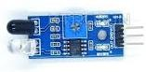

Fig 4.6:IR Proximity sensor

Here, the transmitter is IR LED whereas the receiver is IR photodiode.

The infrared photodiode is responsive to the infrared light that is generated through an infrared LED. The resistance of photo-diode & the change in output voltage is in proportion to the infrared light obtained. This is the IR sensor’s fundamental working principle.

Once the infrared transmitter generates emission, then it arrives at the object & some of the emission will reflect back toward the infrared receiver.

The sensor output can be decided by the IR receiver depending on the intensity of the response.

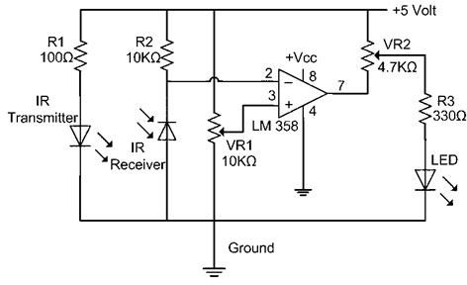

Fig 4.6: Internal circuit of IR Proximity sensor

## APPLICATIONS

* Climatology
* Meteorology
* Photo biomodulation
* Flame Monitors
* Gas detectors
* Water analysis
* Moisture Analyzers
* Anesthesiology testing

## ULTRA SONIC SENSOR :-

* + 1. **GENERAL DESCRIPTION :-**

Ultrasonic sensors are electronic devices that calculate the target’s distance by emission of ultrasonic sound waves and convert those waves into electrical signals. The speed of emitted ultrasonic waves traveling speed is faster than the audible sound.

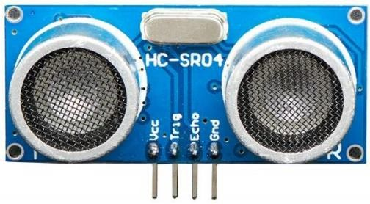

Fig 4.7: Ultra Sonic sensor

* + 1. PRODUCT DESCRIPTION :-

The ultrasonic sensor works on the same principles as a radar system

. An ultrasonic sensor can convert electrical energy into acoustic waves and vice versa. The acoustic wave signal is an ultrasonic wave traveling at a frequency above 18kHz.

The famous HC SR04 ultrasonic sensor generates ultrasonic waves at 40kHz frequency.

Typically, a microcontroller is used for communication with an ultrasonic sensor.

To begin measuring the distance, the microcontroller sends a trigger signal to the ultrasonic sensor.

The duty cycle of this trigger signal is 10µS for the HC-SR04 ultrasonic sensor.

When triggered, the ultrasonic sensor generates eight acoustic (ultrasonic) wave bursts and initiates a time counter. As soon as the reflected (echo) signal is received, the timer stops.

The output of the ultrasonic sensor is a high pulse with the same duration as the time difference between transmitted ultrasonic bursts and the received echo signal.

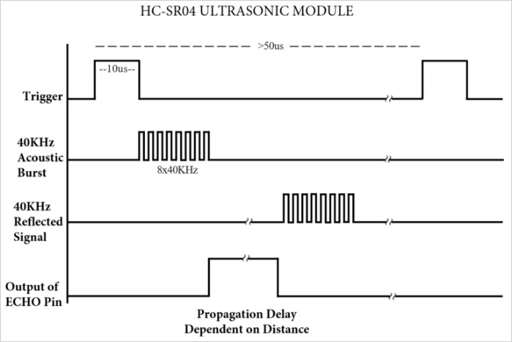

## Fig 4.7: Representation of trigger signal, acoustic bursts, reflected signal and output of echo pin.

* + 1. 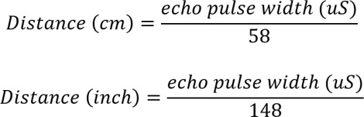FORMULAE USED :-
    2. SPECIFICATIONS:-

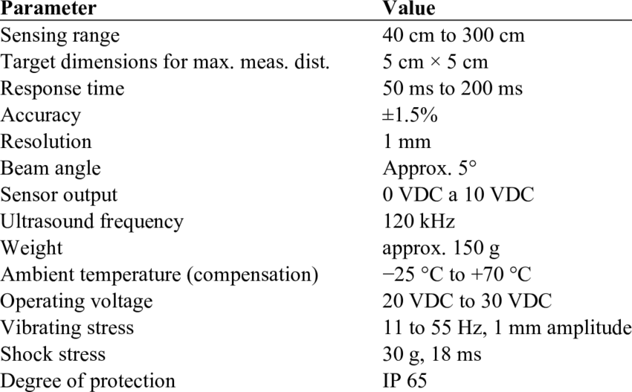

# CHAPTER 5 - SOFTWARE REQUIREMENT

## Google Assistant

Google Assistant is Google's voice assistant. When it launched, Google Assistant was an extension of Google Now, designed to be personal while expanding on Google's existing "OK Google" voice controls.

Originally, Google Now smartly pulled out relevant information for you. It knew where you worked, your meetings and travel plans, the sports teams you liked, and what interested you so that it could present you with information that mattered to you.

Google has long killed Google Now, but Assistant lives in the same space, fusing these personalized elements with a wide-range of voice control. Google Assistant supports both text or voice entry and it will follow the conversation whichever entry method you're using.

## Google Assistant on Phone

Google expanded its Google Assistant service in 2017 so that it would be available on more mobile devices. That saw the roll-out of Assistant to most Android phones, with all recent launches offering the AI system. Even devices that offer another AI system, like Samsung's Bixby, also offer Google Assistant. Essentially, if your phone has Android, your phone has Google Assistant, so the user base for Google Assistant is huge. It's possible to have Assistant respond to you even when your Android phoneis locked too, if you opt-in through your settings and you can also opt in to see answers to

personal queries too.

Google Assistant is also available on the iPhone, although there are some restrictions. So, Google Assistant is no longer the preserve of Pixel phones; it's something that all Android users and even iOS users can enjoy.

## Features

* + - * + Ease to Check-in Flights
        + Opportunity to Book a Hotel
        + See Traffic on Locked Device
        + Make Phone Calls for Appointments
        + Do Image Search
        + Find Nearby Places
        + Get Weather Forecast
        + To Practice a New Language
        + Convert Currencies and Measurements

## Software Description

* + 1. **Arduino Software (IDE)**

Get the latest version from the download page. You can choose between the Installer (.exe) and the Zip packages. We suggest you use the first one that installs directly everything you need to use the Arduino Software (IDE), including the drivers. With the Zip package you need to install the drivers manually. The Zip file is also useful if you want to create a [portable installation](https://www.arduino.cc/en/Guide/PortableIDE).

When the download finishes, proceed with the installation and please allow the driver installation process when you get a warning from the operating system.

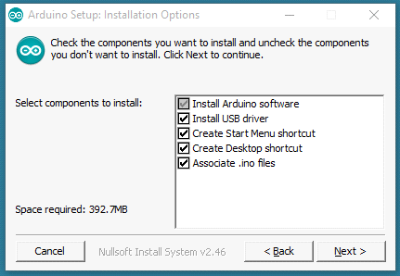

Fig5.1 : Arduino setup: Installation Options Choose the components to install

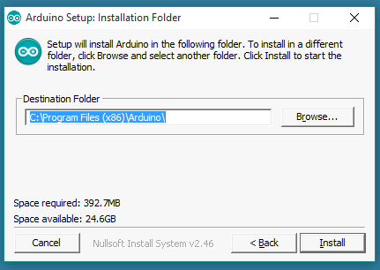

Fig5.2: Arduino Setup: Installation Folder Choose the installation directory (we suggest to keep the default one)

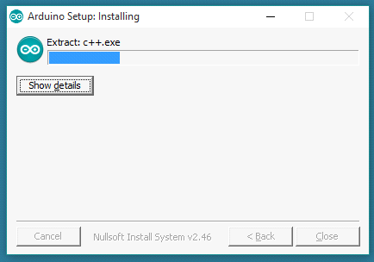

Fig5.3: Arduino Setup: Installing

The process will extract and install all the required files to execute properly the Arduino Software (IDE)

.

## 5..2.2 Hardware Needed

To burn the source code onto the ARDUINO UNO, we will need a standard USB cable (A plug to B plug), the kind you would connect to a USB printer as shown in the figure 5.4

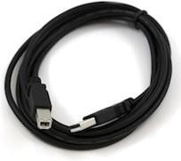

Fig5.4: USB cable

## Using another Arduino as an ISP

* Your Arduino UNO (to program)
* A Working Arduino (doesn't matter what kind)
* Some Male-to-Male Jumper Cables

For instructions on this method, take a look at the SparkFun.com website: <http://www.sparkfun.com/tutorials/247>

## SOURCE CODE :-

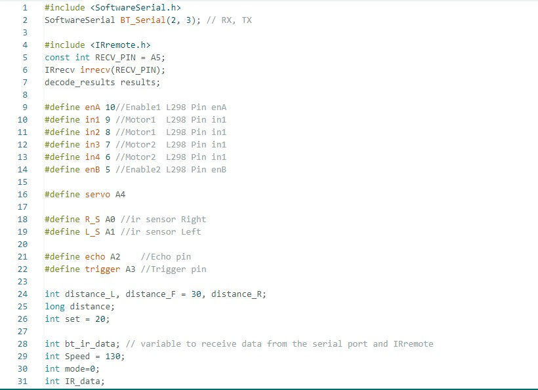

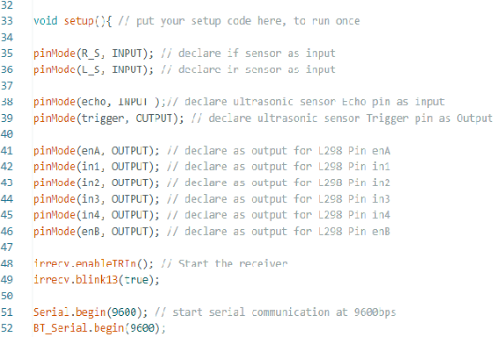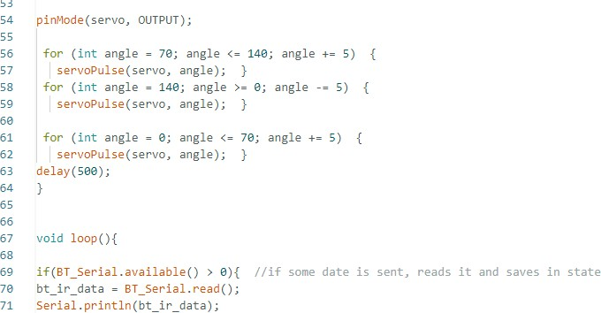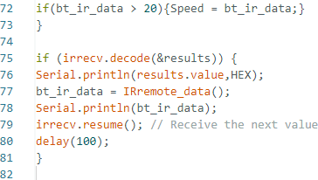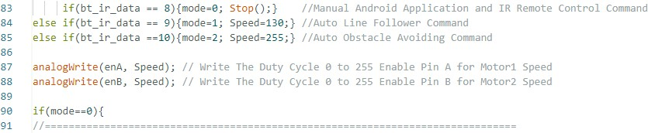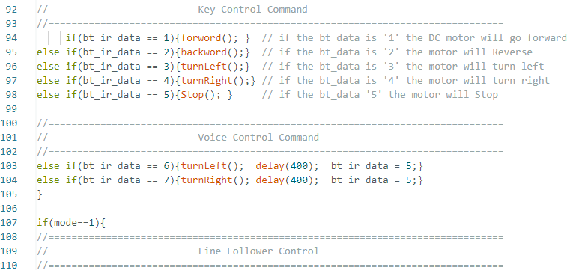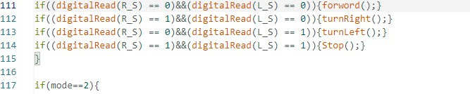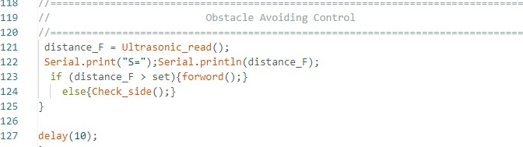

```

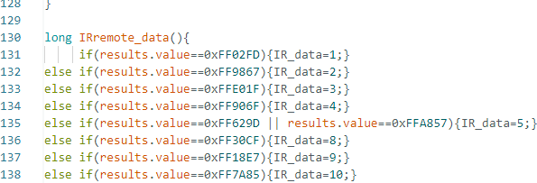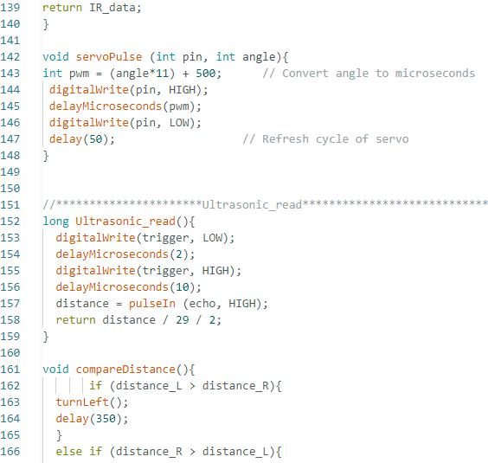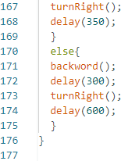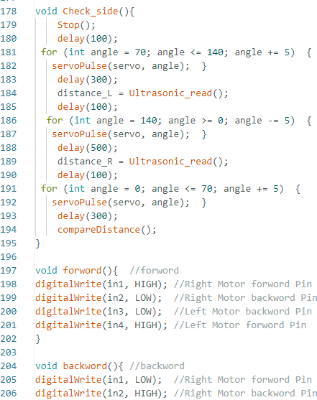

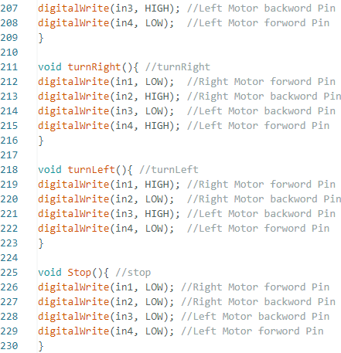

## SUMMARY:-

|  |  |
| --- | --- |
| Microcontroller | Arduino UNO |
| Operating Voltage | 5V Input Voltage (recommended) |
| Input Voltage (limits) | 6-20V |
| Digital I/O Pins | 54 (of which 14 provide PWM output) |
| Analog Input Pins | 16 |
| DC Current per I/O Pin | 40mA |
| DC Current for3.3VPin | 50mA |
| Flash Memory | 256 KB of which 8 KB used by  bootloader |
| SRAM | 8KB |
| EEPROM | 4KB |
| Lock Speed | 16MHz |

Table5.1: Summary of Technical Details

## TECHNICAL DETAILS:-

The Arduino UNO can be powered via the USB connection or with an external power supply. The power source is selected automatically. External (non-USB) power can come either from an AC-to-DC adapter (wall-wart) or battery. The adapter can be connected by plugging a 2.1mm center-positive plug into the board's power jack. Leads from a battery can be inserted in the GND and Vin pin headers of the POWER connector.

The board can operate on an external supply of 6 to 20 volts. If supplied with less than 7V, however, the 5V pin may supply less than five volts and the board may be unstable. If using more than 12V, the voltage regulator may overheat and damage the board. The recommended range is 7 to 12 volts.

They differs from all preceding boards in that it does not use the FTDI USB-to- serial driver chip. Instead, it features the programmed as a USB-to-serial converter.

## The power pins are as follows:

* + - * **VIN.** The input voltage to the Arduino board when it's using an external power source (as opposed to 5 volts from the USB connection or other regulated power source). You can supply voltage through this pin, or, if supplying voltage via the power jack, access it through this pin.
      * **5V.** The regulated power supply used to power the microcontroller and other components on the board. This can come either from VIN via a non- board regulator, or be supplied by USB or another regulated 5V supply.
      * **3V3.**A3.3voltsupplygeneratedbytheon- boardregulator.Maximumcurrentdrawis50 mA.
      * **GND.** Ground pins.

The ATMEGA has 256 KB of flash memory for storing code (of which 8 KB is used for the boot loader), 8 KB of SRAM and 4 KB of EEPROM.

Each of the 54 digital pins on the Mega can be used as an input or output, using [pinMode()](http://arduino.cc/en/Reference/PinMode), [digitalWrite(),](http://arduino.cc/en/Reference/DigitalWrite)and [digitalRead()](http://arduino.cc/en/Reference/DigitalRead)functions. They operate at 5 volts. Each

pin can provide or receive a maximum of 40 mA and has an internal pull-up resistor (disconnected by default) of 20-50k Ohms. In addition, some pins have specialized functions:

* + - * **Serial: 0 (RX) and 1 (TX); Serial 1: 19 (RX) and 18 (TX); Serial 2: 17 (RX) and 16 (TX); Serial 3: 15 (RX) and 14 (TX).** Used to receive (RX) and transmit (TX) TTL serial data. Pins 0 and 1 are also connected to the corresponding pins of the ATMEGA USB-to-TTL Serial chip.
      * **External Interrupts: 2 (interrupt 0), 3 (interrupt 1), 18 (interrupt 5), 19 (interrupt 4), 20 (interrupt 3), and 21 (interrupt 2).** These pins can be configured to trigger an interrupt on a low value, a rising or falling edge, or a changing value.
      * **PWM: 0to13.** Provide 8-bit PWM output with the [analogWrite()](http://arduino.cc/en/Reference/AnalogWrite) function.
      * **SPI: 50 (MISO), 51 (MOSI), 52 (SCK), 53 (SS).** These pins support SPI communication, which, although provided by the underlying hardware, is not currently included in the Arduino language. The SPI pins are also broken out on the ICSP header, which is physically compatible with the Duemilanove and Diecimila.
      * **LED: 13.** There is a built-in LED connected to digital pin 13. When the pin is HIGH value, the LED is on, when the pin is LOW, it's off.
      * **I2C: 20 (SDA) and 21 (SCL).** Support I2C (TWI) communication using the [Wire library](http://wiring.org.co/reference/libraries/Wire/index.html) (documentation on the Wiring website). Note that these pins are not in the same location as the I2C pins on the Duemilanove.

The Arduino UNO has 16 analog inputs, each of which provide 10 bits of resolution (i.e. 1024 different values). By default they measure from ground to 5 volts, though is it possible to change the upper end of their range using the AREFpin and analog Reference() function.

There are a couple of other pins on the board:

* + - * **AREF.** Reference voltage for the analog inputs. Used with [analog](http://arduino.cc/en/Reference/AnalogReference) [Reference](http://arduino.cc/en/Reference/AnalogReference)().
      * **ESET.** Bring this line LOW to reset the microcontroller. Typically used to add a reset button to shields which block the one on the board.

## Communication

The Arduino UNO has a number of facilities for communicating with a computer, another Arduino, or other microcontrollers. The Arduino UNO provides four hardware UARTs for TTL (5V) serial communication.

An ATMEGA on the board channels one of these over USB and provides a virtual comport to software on the computer (Windows machines will need a .inf file, but OSX and Linux machines will recognize the board as a COM port automatically. The Arduino software includes a serial monitor which allows simpletextual data to be sent to and from the board. The RX and TX LEDs on the board will flash when data is being transmitted

via the ATmega8U2 chip and USB connection to the computer (but not for serial communication on pins 0 and1).pins.

The Arduino UNO also supports I2C (TWI) and SPI communication. The Arduino software includes a Wire library to simplify use of the I2C bus; see the

## Programming

The Arduino UNO can be programmed with the Arduino software (ARDUINO

IDE)..

The Arduino UNO on the Arduino UNO comes pre burned with a [bootloader](http://arduino.cc/en/Tutorial/Bootloader) that allows you to upload new code to it without the use of an external hardware programmer. It communicates using the original STK500 protocol).

## Automatic (Software) Reset

Rather than requiring a physical press of the reset button before an upload, the Arduino UNO is designed in a way that allows it to be reset by software running ona connected computer. One of the hardware flow control lines (DTR) of theATmega8U2 is connected to the reset line of the Arduino UNO via a 100 nano-farad capacitor. When this line is asserted (taken low), the reset line drops long enough to reset the chip. The Arduino software uses this capability to allow you to upload code by simply pressing the upload button in the Arduino environment. This means that the bootloader can have a shorter timeout, as the lowering of DTR can be well- coordinated with the start of the upload.

This setup has other implications. When the Arduino UNO is connected to either a computer running Mac OS X or Linux, it resets each time a connection is

made to it from software (via USB). For the following half-second or so, the bootloader is running on the UNO. While it is programmed to ignore malformed data (i.e. anything

besides an upload of new code), it will intercept the first few bytes of data sent to the board after a connection is opened. If a sketch running on the board receives one-time configuration or other data when it first starts, make sure that the software with which it communicates waits a second after opening the connection and before sending this data.

The Mega contains a trace that can be cut to disable the auto-reset. The pads on either side of the trace can be soldered together to re-enable it. It's labeled "RESET-EN". You may also be able to disable the auto-reset by connecting a 110 ohm resistor from 5V to the reset line; see this forum thread for details.

## USB Over current Protection

* + 1. **Physical Characteristics and Shield Compatibility**

The Arduino UNO has a resettable poly fuse that protects your computer's USB ports from shorts and over current. Although most computers provide their own internal protection, the fuse provides an extra layer of protection. If more than 500Ma is applied to the USB-port, the fuse will automatically break the connection until the short or overload is removed.

The maximum length and width of the UNO PCB are 4 and 2.1 inches respectively, with the USB connector and power jack extending beyond the former dimension. Three screw holes allow the board to be attached to a surface or case. Note that the distance between digital pins 7 and 8 is 160 mil (0.16"), not an even multiple of the 100 mm spacing of the other pins.

The UNO is designed to be compatible with most shields designed for the Diecimila or Duemilanove. Digital pins 0 to 13 (and the adjacent AREF and GND pins), analog inputs 0 to 5, the power header, and ICSP header are all in equivalent locations.

Further the main UART (serial port) is located on the same pins (0 and 1),as are external interrupts 0 and 1 (pins 2 and 3 respectively). SPI is available through the ICSP header on both the Mega and Duemilanove / Diecimila.

Please note that I2C is not located on the same pins on the Mega (20and21) as the Duemilanove / Diecimila (analog inputs 4 and 5).

## Instructions to use Arduino

Arduino can sense the environment by receiving input from a variety of sensors and can affect its surroundings by controlling lights, motors, and other actuators and the Arduino development environment. Arduino projects can be stand-alone or they can communicate with software on running on a computer

Arduino is a cross-platform program. You’ll have to follow different instructions for your personal OS.

Once you have downloaded/unzipped the arduino IDE, you can plug the Arduino to your PC via USB cable.

## EMBEDDED C

* + 1. **ABOUT EMBEDDED C**

High-level language programming has long been in use for embedded-systems development. However, assembly programming still prevails, particularly for digital- signal processor (DSP) based systems. DSPs are often programmed in assembly language by programmers who know the processor architecture inside out. The key motivation for this practice is performance, despite the disadvantages of assembly programming when compared to high-level language programming.

If the video decoding takes 80 percent of the CPU-cycle budget instead of 90 percent, for instance, there are twice as many cycles available for audio processing. This coupling of performance to end-user features is characteristic of many of the real-time applications in which DSP processors are applied. DSPs have a highly specialized architecture to achieve the performance requirements for signal processing applications within the limits of cost and power consumption set for consumer applications. Unlike a conventional Load-Store (RISC) architecture, DSPs have a data path with memory- access units that directly feed into the arithmetic units. Address registers are taken out of the general-purpose register file and placed next to the memory units in a separate register file.

A further specialization of the data path is the coupling of multiplication and addition to form a single cycle Multiply-accumulate unit (MAC). It is combined with special-purpose accumulator registers, which are separate from the general- purpose registers. Data memory is segmented and placed close to the MAC to achieve the high bandwidths required to keep up with the streamlined data path. Limits are often placed on the extent of memory-addressing operations. The

localization of resources in the data path saves many data movements that typically take place in a Load-Store architecture.

The most important, common arithmetic extension to DSP architectures is the handling of saturated fixed-point operations by the arithmetic unit. Fixed-point arithmetic can be implemented with little additional cost over integer arithmetic. Automatic saturation (or clipping) significantly reduces the number of control-flow instructions needed for checking overflow explicitly in the program. Changes in technological and economic requirements make it more expensive to continue programming DSPs in assembly. Staying with the mobile phone as an example, the

signal-processing algorithms required become increasingly complex. Features such as stronger error correction and encryption must be added. Communication protocols become more sophisticated and require much more code to implement. In certain markets, multiple protocol stacks are implemented to be compatible with multiple service providers. In addition, backward compatibility with older protocols is needed to stay synchronized with provider networks that are in a slow process of upgrading.

Today, most embedded processors are offered with C compilers. Despite this, programming DSPs is still done in assembly for the signal processing parts or,at best, by using assembly-written libraries supplied by manufacturers. The key reason for this is that although the architecture is well matched to the requirements of the signal- processing application, there is no way to express the algorithms efficiently and in a natural way in Standard C. Saturated arithmetic.

For example, is required in many algorithms and is supplied as a primitive in many DSPs. However, there is no such primitive in Standard C. To express saturated arithmetic in C requires comparisons, conditional statements, and correcting assignments. Instead of using a primitive, the operation is spread over a

number of statements that are difficult to recognize as a single primitive by a compiler.

## DESCRIPTION

Embedded C is designed to bridge the performance mismatch between Standard C and the embedded hardware and application architecture. It extends the C language with the primitives that are needed by signal-processing applications and that are commonly provided by DSP processors. The design of the support for fixed-point data

types and named address spaces in Embedded C is based on DSP-C. DSP-C [1] is an industry-designed extension of C with which experience was gained since 1998 by various DSP manufacturers in their compilers. For the development of DSP-C by ACE (the company three of us work for), cooperation was sought with embedded- application designers and DSP manufacturers.

The Embedded C specification extends the C language to support freestanding embedded processors in exploiting the multiple address space functionality, user-defined named address spaces, and direct access to processor and I/O registers. These features are common for the small, embedded processors used in most consumer products. The features introduced by Embedded C are fixed-point and saturated arithmetic, segmented memory spaces, and hardware I/O addressing. The description we present here addresses the extensions from a language-design perspective, as opposed to the programmer or processor architecture perspective.

## MULTIPLE ADDRESS SPACES

Embedded C supports the multiple address spaces found in most embedded systems. It provides a formal mechanism for C applications to directly access (or map onto) those individual processor instructions that are designed for optimal

memory access. Named address spaces use a single, simple approach to grouping memory locations into functional groups to support MAC buffers in DSP applications, physical separate memory spaces, direct access to processor registers, and user-defined address spaces.

The Embedded C extension supports defining both the natural multiple address space built into a processor's architecture and the application-specific address space that can help define the solution to a problem.

Embedded C uses address space qualifiers to identify specific memory spaces in variable declarations. There are no predefined keywords for this, as the actual memory segmentation is left to the implementation. As an example, assume that **X** and **Y** are memory qualifiers. The definition:

X int a[25] ;

Means that **a** is an array of 25 integers, which is located in the **X** memory. Similarly(but less common):

X int * Y p ;

Means that the pointer **p** is stored in the **Y** memory. This pointer points to integer data that is located in the **X** memory. If no memory qualifiers are used, the data is stored into unqualified memory.

For proper integration with the C language, a memory structure is specified, where the unqualified memory encompasses all other memories. All unqualified pointers are pointers into this unqualified memory. The unqualified memory

abstraction is needed to keep the compatibility of the **void \*** type, the **NULL** pointer, and to avoid duplication of all library code that accesses memory through pointers that are passed as parameters.

## NAMED REGISTERS

Embedded C allows direct access to processor registers that are not addressable in any of the machine's address spaces. The processor registers are defined by the compiler- specific, named-register, storage class for each supported processor. The processor registers are declared and used like conventional C variables.

Developers using Embedded C can now develop their applications, including direct access to the condition code register and other processor-specific status flags, in a high-level language, instead of inline assembly code.

Named address spaces and full processor access reduces application dependency on assembly code and shifts the responsibility for computing data types, array and structure offsets, and all those things that C compilers routinely and easilydo from developers to compilers.

## I/O HARDWARE ADDRESSING

The motivation to include primitives for I/O hardware addressing in Embedded C is to improve the portability of device-driver code. In principle, a hardware device driver should only be concerned with the device itself. The driver operates on the device through device registers, which are device specific. However, the method to access these registers can be very different on different systems, eventhough it is the same device that is connected. The I/O hardware access primitives

aim to create a layer that abstracts the system-specific access method from the device that is accessed. The ultimate goal is to allow source-code portability of device drivers between different systems. In the design of the I/O hardware-addressing interface, three requirements needed to be fulfilled:

* The device-drive source code must be portable.
* The interface must not prevent implementations from producing machine code that is as efficient as other methods.
* The design should permit encapsulation of the system-dependent access method.

The design is based on a small collection of functions that are specified in the

<iohw.h> include file. These interfaces are divided into two groups; one group provides access to the device, and the second group maintains the access method abstraction itself.

To access the device, the following functions are defined by Embedded C: unsigned int iord( ioreg_designator );

void iowr( ioreg_designator, unsigned int value ); void ioor( ioreg_designator, unsigned int value ); void ioand( ioreg_designator, unsigned int value

);void ioxor( ioreg_designator, unsigned int value

);

These interfaces provide read/write access to device registers, as well as typical methods for setting/resetting individual bits. Variants of these functions are defined(with **buf** appended to the names) to access arrays of registers. Variants are also defined (with l appended) to operate with **long** values.

All of these interfaces take an I/O register designator **ioreg_designator** as one of the arguments. These register designators are an abstraction of the real registers provided by the system implementation and hide the access method from the driver source code. Three functions are defined for managing the I/O register designators. Although these are abstract entities for the device driver, the driver does have the obligation to initialize and release the access methods. These functions do not access or initialize the device itself because that is the task of the driver. They allow, for example, the operating system to provide a memory mapping of the device in the user address space.

void iogroup_acquire( iogrp_designator );void iogroup_release( iogrp_designator );

void iogroup_map( iogrp_designator, iogrp_designator );

The **iogrp_designator** specifies a logical group of I/O register designators; typically this will be all the registers of one device. Like the I/O register designator, the I/O group designator is an identifier or macro that is provided by the system implementation. The map variant allows cloning of an access method when one device driver is to be used to access multiple identical devices.

## EMBEDDED C PORTABILITY

By design, a number of properties in Embedded C are left implementation defined. This implies that the portability of Embedded C programs is not always guaranteed. Embedded C provides access to the performance features of DSPs. As not all processors are equal, not all Embedded C implementations can be equal For example, suppose an application requires 24-bit fixed-point arithmetic and an

Embedded C implementation provides only 16 bits because that is the native size of the processor. When the algorithm is expressed in Embedded C, it will not produce outputs of the right precision.

In such a case, there is a mismatch between the requirements of the application and the capabilities of the processor. Under no circumstances, including the use of assembly, will the algorithm run efficiently on such a processor. Embedded C cannot overcome such discrepancies. Yet, Embedded C provides a great improvement in the portability and software engineering of embedded applications. Despite many differences between

performance-specific processors, there is a remarkable similarity in the special-purpose features that they provide to speed up applications.

Writing C code with the low-level processor-specific support may at first appear to have many of the portability problems usually associated with assembly code. In the limited experience with porting applications that use Embedded C extensions, an automotive engine controller application (about 8000 lines of source)was ported from the eTPU, a 24-bit special-purpose processor, to a general-purpose8-bit Freescale 68S08 with about a screen full of definitions put into a single header file. The porting process was much easier than expected. For example, variables that had been implemented on the processor registers were ported to unqualified memory in the general-purpose microprocessor by changing the definitions in the header definition and without any actual code modifications. The exercise was to identify the porting issues and it is clear that the performance of the special-purpose processor is significantly higher than the general-purpose target.

## SYSTEM IMAGE

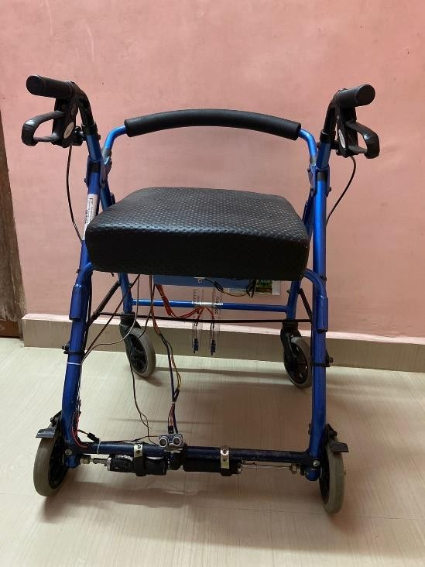

Fig5.5: Front view of system

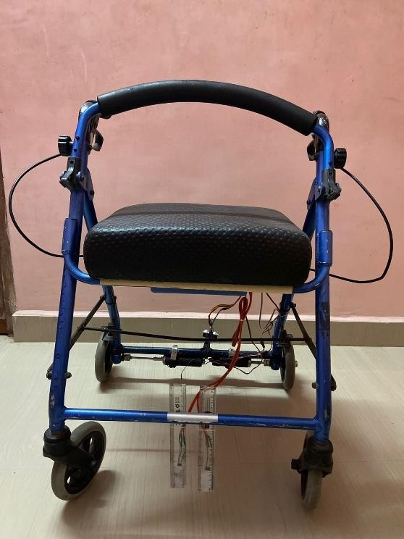

Fig5.6: Back view of system

**EZ CONNECT APP INTERFACE**

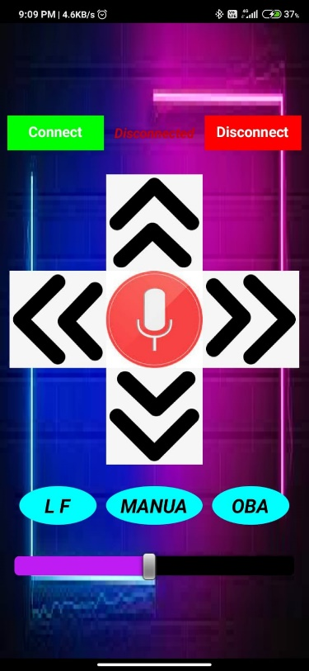

**\**

## WORKING:-

The working of the wheelchair is selected on the basis of the user facility (ie.,IR remote, Line follower, Obstacle avoidance, GOOGLE assistance, Bluetooth joystick controller.) in the EZ CONNECT app. The Google assistance, Joystick controlling is connected by Bluetooth to the EZ CONNECT. The input data is given to the micro controller via the application. The Microcontroller gives the motor driver the command according to the input and the direction of the wheelchair is to be moved. The motor moves by the command by the motor driver. The input for the entire system is given by the 12V battery. The motor used here is 12V Planetary Gear motor. The wheelchair can also be moved manually.

# CHAPTER 6 CONCLUSION AND FUTURE SCOPE

A major challenge in the design of the smart wheelchair is to rapidly, accurately, and sufficiently produce control commands. The cost of the system is less and it gives the reliable output as compared to another system which useful for society. To have safe and it is mainly implemented on a long scale for the better results and problem free solutions in the future.

Due this fast growing world due accident and other reason some may lost the movement and need to depend on others for their movement. Other than accidents due to improper cell division and malnutrition due to the food habits of now a days children may lack limbs. For their movement wheelchair is needed. This voice controlled and wireless controlled wheelchair will be affordable for those disabled peoples. With further development to this system advancement can be done more features can be added.

**REFERENCES**

* + T. F. Bastos-filho, F. A. Cheein, S. Mara, T. Muller, W. C. Celeste, C. D. ¨ Cruz,

D. C. Cavalieri, M.Sarcinelli-filho, P. Faria, S. Amaral, E. Perez, C. M. Soria, R. Carelli, and S. Member(2014) “Towards a New Modality Independent Interface for a Robotic Wheelchair,” vol. 22, no. 3, pp. 567–584.

* + Q. Huang, S. He, Q. Wang, Z. Gu, N. Peng, K. Li, and Y. Zhang(2017) “An EOG- Based Human- Machine Interface for Wheelchair Control,” vol. 9294, no. c, pp. 1– 11.
  + J. Ma, Y. Zhang, A. Cichocki, and F. Matsun(2014) “A Novel EOG / EEG Hybrid Human- Machine Interface Adopting Eye Movements and ERPs :Application to Robot Control,” vol. 9294, no. c, pp. 1–14.
  + A. Maksud, R. I. Chowdhury, T. T. Chowdhury, S. A. Fattah, C. Shahanaz, and

S. S. Chowdhury, Dec(2017) “Low-cost EEG based electric wheelchair with advanced controlfeatures,” vol. 2017-December, pp. 2648–2653.

* + S. K. Sivanath, S. A. Muralikrishnan, and P. Thothadri(2012) “Eyeball and Blink Controlled Firing System for Military Tank Using LabVIEW”.
  + Y. Wang, G. Zhai, S. Zhou, S. Chen, X. Min, and Z. Gao, “Eye Fatigue Assessment Using Unobtrusive Eye Tracker(2013)” IEEE Access, vol. PP, no. c, p.1, J. Xiong, W. Xu, W. Liao, Q. Wang, J. Liu, and Q. Liang, “Eye Control System Base on Ameliorated Hough Transform Algorithm,” vol. 13, no. 9, pp. 3421–3429.
  + W. Zhang, B. Cheng, and Y. Lin,(2012) “Driver Drowsiness Recognition Based on Computer Vision Technology *,” vol. 17, no. 3, pp. 354–362.
  + R. Zhang, S. He, X. Yang, X. Wang, K. Li, Q. Huang, Z. Gu, and Z. Yu,(2018)“An EOG-based Human Machine Interface to Control a Smart Home Environment for Patients with Severe Spinal Cord Injuries,” vol. 9294, no. c, pp. 1–12.